Building Metadata Dataset Preprocessing

The building metadata dataset contains descriptive information about each building included in the ASHRAE energy prediction dataset. It includes attributes such as building ID, site ID, primary building usage category, square footage, year built, and floor count. It has the data of 1449 buildings. This dataset plays an important role in providing contextual information that helps machine learning models understand how building characteristics influence energy consumption patterns.

The dataset represents a diverse collection of buildings distributed across multiple geographic sites. The `site_id` attribute indicates different weather locations, allowing the integration of local climate information with building-level energy usage. Buildings in the dataset belong to 16 different primary usage categories, including education, office, healthcare, lodging/residential, retail, technology/science, and warehouse/storage. Education had the most number of buildings, which was 549. The second most was office buildings with 279 buildings. On the other hand, less than 10 buildings were used for Technology/Science, Food Sales and Service, Utility and Religious Worship. Since these categories are nominal and non-ordinal, One-Hot Encoding was applied to convert them into machine-readable binary features without introducing artificial ordering relationships.
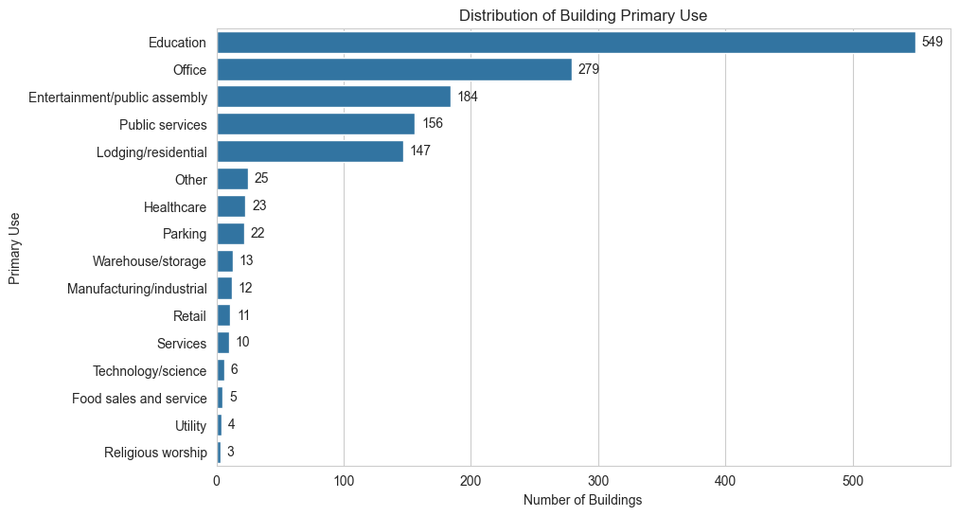
Fig: Primary Use Count

The `square_feet` feature showed a highly skewed distribution with a very large size range between small and large buildings. To reduce skewness and stabilize variance, a logarithmic transformation (`log_square_feet`) was applied using the `log1p()` function. The `year_built` feature was used to derive a new attribute called `building_age`, calculated relative to the dataset year (2016). This transformation allowed the model to capture the effect of building age more effectively than using raw construction years.

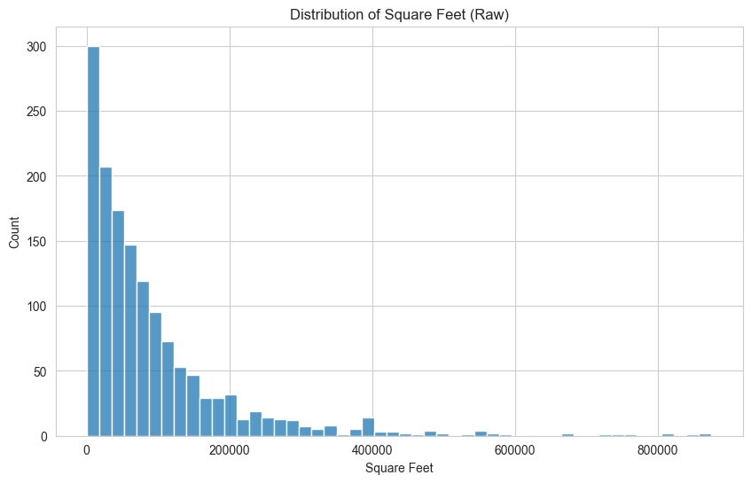 | 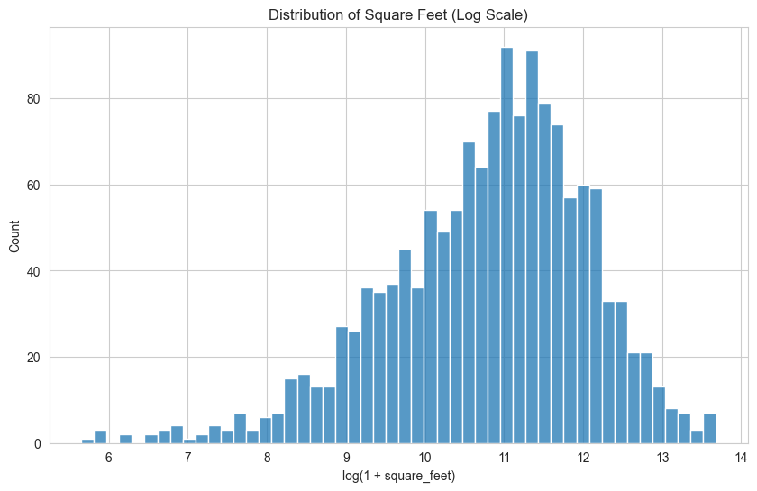
Fig: Square Feet Raw vs Log1p Scaled

Several missing data handling decisions were made during preprocessing. The `floor_count` attribute contained a large proportion of missing values; however, instead of removing the feature entirely, a new binary feature called `missing_floor_count_flag` was created to preserve information about missingness. Missing floor counts were then imputed using grouped median values based on `primary_use`, `site_id`, and building size categories derived from square footage. Missing `year_built` values were similarly imputed using grouped medians by building type and site. These decisions were made to retain potentially useful structural information while minimizing information loss and maintaining dataset consistency for model training.

Limitations:

Despite achieving promising results, the project has several limitations. Firstly, the top-performing models attained an RMSLE of approximately 0.51. This indicates potential, yet it remains a mediocre outcome. Secondly, the substantial size of the dataset posed considerable computational difficulties. The final training dataset contained approximately 20,216,100 records and 49 features, including engineered temporal and weather-related features. Training on the complete dataset required extensive computational resources. . Only two of the six team members were able to train the entire dataset on their personal machines. Furthermore, even Google Colab Enterprise could not train models on the final processed dataset. Due to these computational and time constraints, it was not possible to thoroughly test all preprocessing strategies, feature engineering approaches, and hyperparameter combinations. Additionally, although ensemble-based methods were explored, they did not produce substantial improvements beyond the achieved performance.

Future Work:

Several improvements can be explored in future work to further enhance the performance and robustness of the energy consumption prediction system. More advanced feature engineering techniques, particularly building-specific temporal features and seasonal trend analysis, could improve the model’s ability to capture long-term consumption behavior. Extensive hyperparameter optimization using automated search methods such as Grid Search, Random Search, or Bayesian Optimization may also lead to better predictive performance. Future work could additionally explore transformer-based or recurrent deep learning architectures designed for time-series forecasting. Using more powerful computational resources would allow for more extensive experimentation. Furthermore, incorporating external contextual information such as holidays, occupancy patterns, or regional energy usage trends may help improve prediction accuracy and model generalization.

